3. The Scientific Method
- is a systematic and logical approach to discovering how things in the universe work
- The scientific method is the process followed to investigate phenomena and acquire new knowledge
- This new knowledge is then used to correct or integrate with previous knowledge allowing for further investigations
= an ongoing process
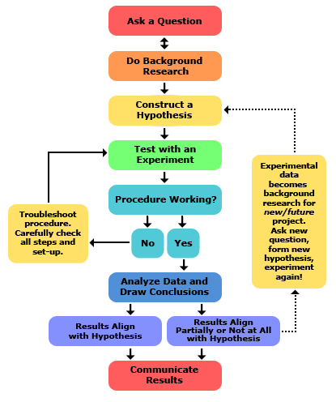

1. Define the Problem (Purpose) This could be stated in the form
of a question.

2. Do Background Research to find out what is already known
about the topic.

3. State a Hypothesis, an “educated guess” as to the answer
to the problem based on reasoning (could be “If ...Then...”)

4. Design & carry out a Controlled Experiment
A. Independent Variable: variable you change on purpose
B. Dependent Variable: variable that responds to a change in
the independent variable (the 1 you are testing for)
C. Constants: variables kept the same in all trials
D. Control: the standard for comparison

5. Data & Observations are made and recorded as the
experiment proceeds.
The 2 types of observations are:
A. Quantitative: numerically measurable
B. Qualitative: changes in characteristics of an object
This data is recorded the in the form of notes, drawings,
tables, graphs, etc

6. Formulate a Conclusion . Analyze and interpret your data to
summarize your findings which support or disproves the
suggested hypothesis.
Monty Python’s Scientific Method

Problem:

Background Information:

Hypothesis:

Materials:

Experiment Description:

Data Collected

Conclusion

- Modern medicine uses the scientific method to determine how effective any particular medicine is.
- This is done using what’s called a “Double Blind Study”, which is a procedure that works something like this:
  - Get your group of subjects, and divide them into three.
  - One group gets the drug.
  - One group gets a placebo, which is a sugar pill.
  - One group gets nothing at all.
  - Monitor the changes.
- No one except for the researchers know who’s in the first group and who’s in the second, because knowing you’re taking the real thing or the placebo, will change how you act, and bias the results.
- The goal is to eliminate bias, so that you get the results of the drug or treatment, rather than their preconceived idea which could influence their behaviour.

Scientific Method Group Project
1) Pick a question to answer.

2) Use the steps of the scientific method to devise an experiment that would
determine an answer for the problem. On loose leaf paper record the
following:
a) The problem you are trying to solve
b) Background information you know / have gathered
c) Hypothesis
d) Design an experiment to test your hypothesis. Be sure to:
i) include a list of materials
ii) describe the experiment
iii) list independent variable, dependent variable, constants & control
iv) describe the type of data you would collect

