AMAZING ATOMS
1. The Atom
The atom is the basic building block of all matter.
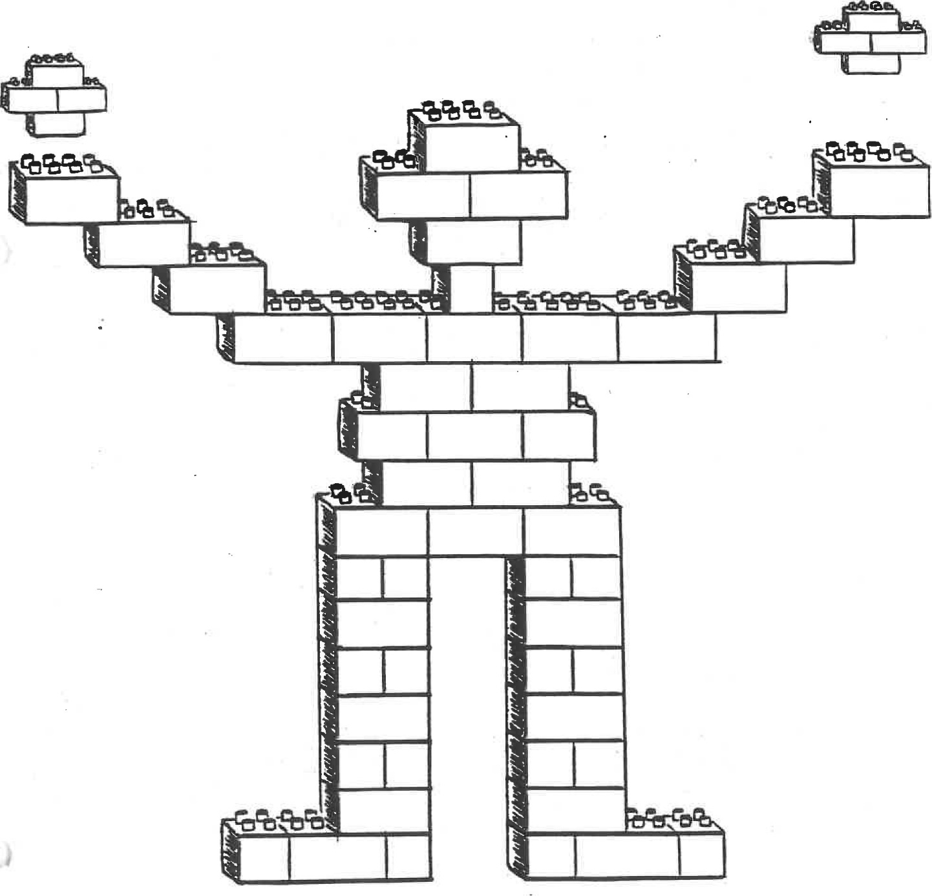
Everything living or dead, solid, liquid or gas is made up of atoms. They can be thought of as "mini-Legos" which all things are made of.
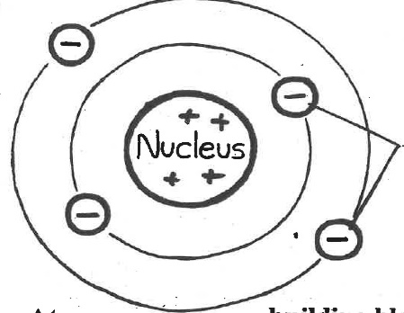
2. Parts of the Atom

Atom - building block of matter
Nucleus | - heavy, central part of the atom  - positive part of the atom  - not able to move easily
Electrons | - lightest and smallest part of the atom which circle the nucleus in "clouds"  - have a negative charge  - able to move which causes electricity
Negative Charge | - objects with extra electrons have a negative charge ( - )
Positive Charge | - objects that have a shortage or have lost electrons have a positive charge(+)
Attraction Laws | - opposites attract and likes repel  (just like magnets)

What is Electricity?
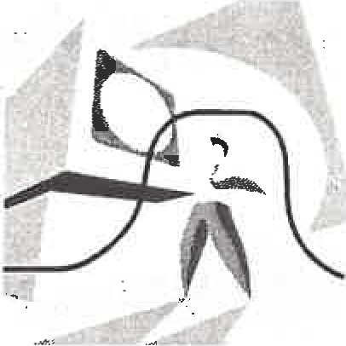
a type of energy
you can't touch, see, smell, or tastes it.... but you can see it's effects
ex) a toaster burns bread
How is electricity made?
> when small particles called electrons from one object/place to another
electricity is not visible b/c electrons are too small to be seen
(Recall: an atom)
Atom- the smallest part of matter
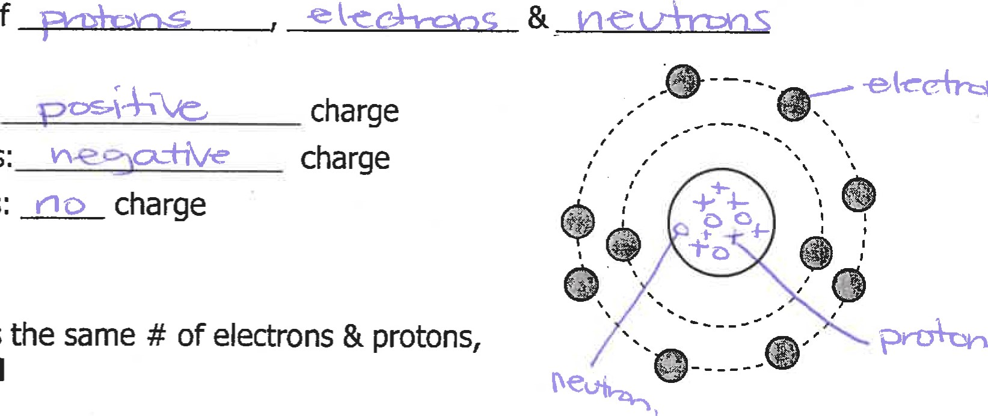
- made up of:
protons:
electrons:
Neutrons:

-when an atom has the same # of it is called: neutral
**When 2 types of matter are brought into close contact, one may lose electrons
- whateverthe electrons becomes POSITIVE
- whatevermore electrons becomes NEGATIVE
ex) when you brush your hair in winter, your hair will become positively charged and your brush will become negatively charged

