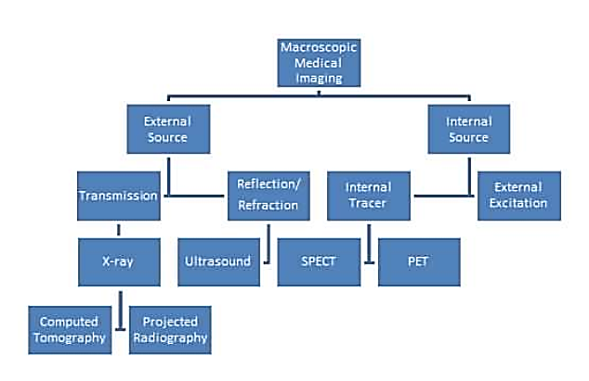

MEDICAL IMAGING TOOLS
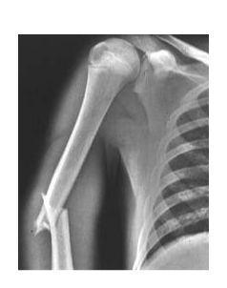
X-ray:
- radiation
- An X-ray machine is made up of a cathode and an anode.
- The machine passes current through the cathode and the positively
charged anode (made of tungsten) draws the negatively charged
electrons towards it.
- When the high speed electrons hit the tungsten atoms in the anode, they collide with enough force to cause electrons in tungsten's lower orbitals to be knocked loose.
-This, in turn, causes electrons in higher energy levels to fall and release photons of energy, known as X-ray photons.
- These x-rays can then be absorbed by calcium atoms in the bones of your body and produce images.
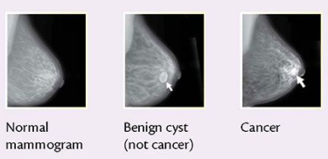
Mammogram:
- radiation
- A woman's breast is compressed between 2 plates in order to flatten the breast and spread the tissue apart (provides a better picture and allows less radiation to be used).
- X-rays are then used to generate images from 2 different angles of each breast.

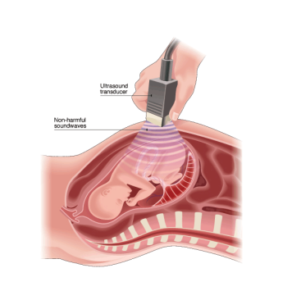
Ultrasound:
- sound
- High frequency sound pulses are transmitted into your body using a probe. - The sound waves travel into your body and hit a boundary between tissue, some are reflected back.
-The machine calculates the distance from the probe to the tissue, and the time it takes to be reflected back, then the machine displays the distances as a two-dimensional image on the screen.

CT (Computerized Tomography):
- radiation
- Uses a motor to revolve an X-ray tube and detectors around the patient's body in order to
scan the soft tissues with differing intensities.
= able to produce a 3-D image
- The computer then combines all the information from each of the scans in order to form a
detailed image of the body.
~ cheaper, more available, only takes approximately 15 mins

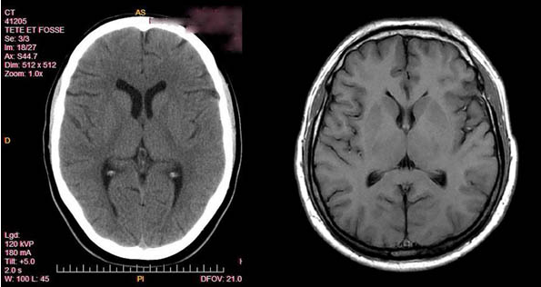

MRI (Magnetic Resonance Imaging):
- magnetic field and sound
- The human body is made up mostly of water and when placed in a magnetic field, all H+ atoms
will align in either a north/south direction.
-The ones that don't align will spin, and once the magnetic resonance force that has been applied to them stops, they go back to a resting state.
- As they do this, they emit energy that sends a signal to a computer, and, this signal can be converted into an image using a mathematical formula.
- very expensive and not as available
- time consuming ~45 min per scan

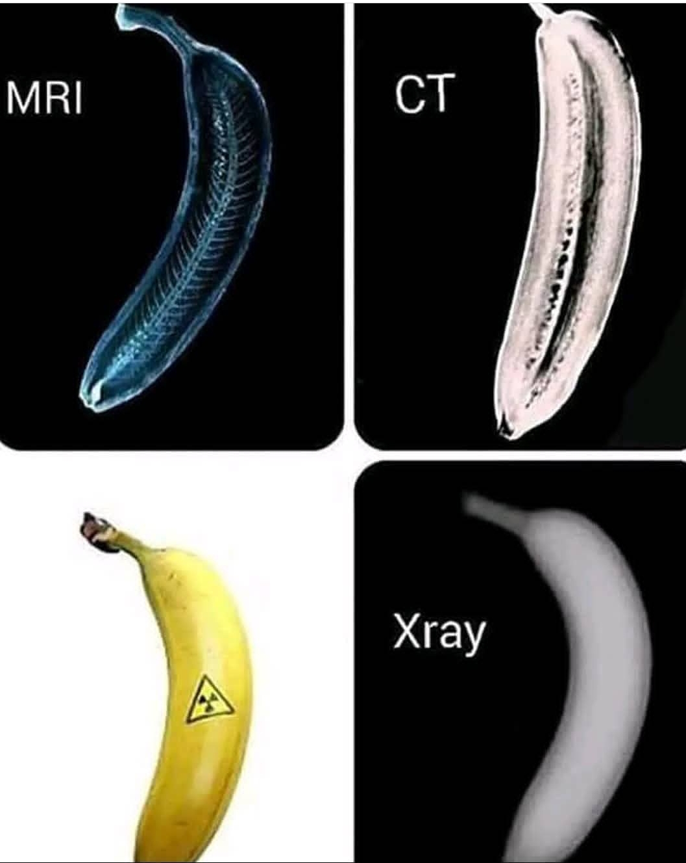

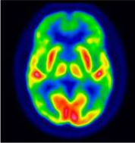
PET (Positron Emission Tomography):
- nuclear medicine
- Produces images of the body by detecting radiation emitted
from radioactive substances.
- In a PET scan, there are millions of crystals that convert the gamma rays given off into photons of light, and eventually electrical signals that are then processed by the computer and used to generate images.
- $$$ expensive

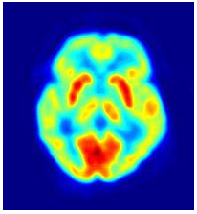
SPECT (Single Photon Emission Computed Tomography):
- nuclear medicine
- Like a PET scan, produces images by detecting radiation given off by radioactive tracers.
However the tracer remains localized to the blood instead of being absorbed by the tissues
= lower resolution and cheaper.

- Uses CT technology to produce a tomographic image.
- can watch the functioning live

