Electron Arrangement

The key to understanding the formation of compounds is to understand the arrangement of electrons about the nucleus.

The Bohr-Rutherford model of the atom states that electrons travel in orbits about a positively charged nucleus. The farther away an electron is from the nucleus, the greater is its energy and the more likely it is to be involved in chemical change. Thus, the electrons in the outer orbit are involved in bonding.

1. Bohr Diagrams
- Show the arrangement of parts of the atom, especially the arrangements of electrons in each orbit.

- Each orbit can only hold a certain number of electrons. The first orbit (nearest the nucleus) will only hold 2 electrons, the second holds 8, and the third is also full when it has 8 electrons.
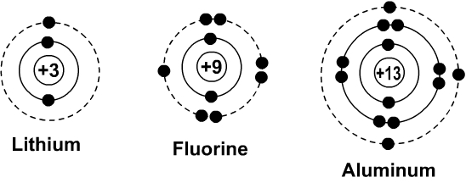
Bohr diagrams for lithium, fluorine, and aluminum.

To work out the electronic arrangement of an atom
- Look up the atomic number in the Periodic Table. This tells you the number of protons, and hence the number of electrons.
- Arrange the electrons in levels, always filling up an inner level before you go to an outer one.
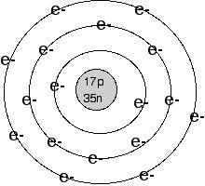
e.g. to find the electronic arrangement in chlorine
- The Periodic Table gives you the atomic number of 17.
- Therefore there are 17 protons and 17 electrons.
- The arrangement of the electrons will be 2, 8, 7 (i.e. 2 in the first level, 8 in the second, and 7 in the third).
2. Lewis Dot Diagrams (or Electron Dot Structures)
- Shows the arrangement of electrons in the outer orbit (called the valence shell) only. The electrons in the valence shell are called valence electrons.

- Uses the symbol of the element to replace the nucleus and inner orbit electrons. The electrons in the valence shell are shown as dots placed around the symbol.

Li F Al

Lewis dot diagrams for lithium, fluorine, and aluminum.

To draw the Lewis structure for an element
- Write the symbol of the atom you are drawing.
- Locate the element on the periodic table of elements. Find the number of valence electrons.
- Each valence electron is represented by a single dot. The dots begin on the right side of the symbol and go counter clockwise around the atom.
- The maximum number of valence electron dots in the Lewis electron dot diagram is 8. Two electrons can go on each side (top, bottom, left, and right).

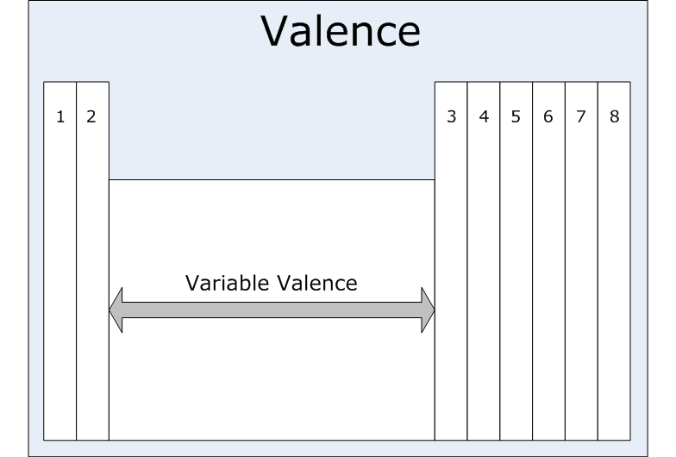
e.g. to draw the Lewis structure for chlorine
- The Periodic Table gives you the symbol Cl and tells you it has 7 valence electrons.
- You start putting dots on the right side of the Cl and continue until you have 7 dots shown.
Cl

General Notes on Electrons

- The electrons in the outer orbit (valence electrons) are responsible for the chemical behavior of each element.

- When elements forms compounds, changes occur in the arrangement of electrons.

- In some compounds, electrons are transferred from one atom to another so that the atoms can have the stable electron arrangements of the noble gases (8 valence electrons).

