Scientific Method
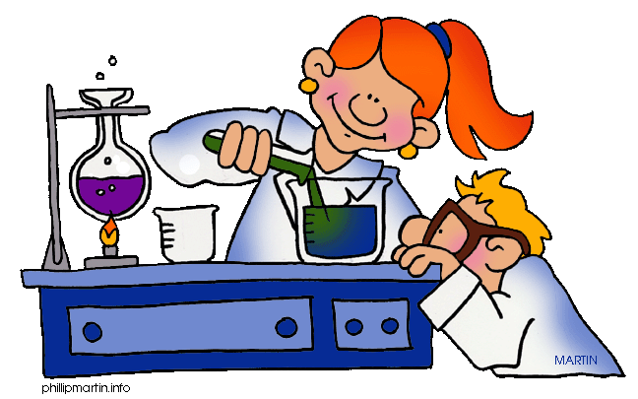
What is it?
- The process used to find answers to questions about the world!

Is there only one?
- Nope – there are many versions but they all have the following steps in common.

Steps
- Ask a Question
- Do Background Research
- Construct a Hypothesis
- Test Your Hypothesis by Doing an Experiment
- Make Observations
- Analyze Data and Draw a Conclusion

Purpose/Question- What do you want to learn? What is the problem to be solved?

Research- Find out as much as you can about the topic.

Hypothesis- Predict the answer to the problem. This is usually stated like " If I...(do something) then...(this will occur)"

Experiment- The fun part! Design a test or procedure to find out if your hypothesis is correct.

Observations- Use your senses to observe information about what happened during the experiment. Record this data.

Analysis & Conclusion- Review the data. Check to see if your hypothesis was correct. Summarize the experiment.

Additional Terms to Know

Experiments include two types of variables (things that change):
Independent Variable
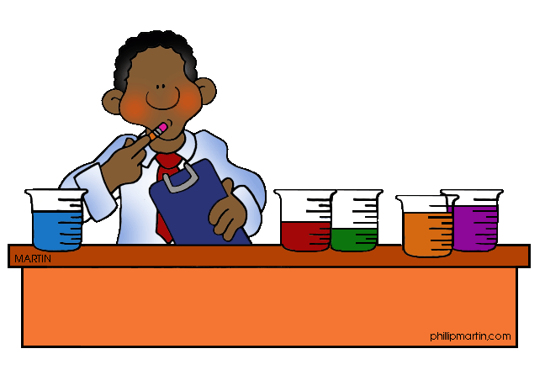

- This is the part of your experiment that you will change on purpose to test your hypothesis.

Dependent Variable
- This is what occurs in response to the changing independent variable.

Control Group
- It is part of the experiment where you do not include the Independent Variable. The control helps you judge your experimental results.

Observations can be:
Quantitative
- Information gathered by measuring
&
Qualitative
- Information gathered by observing (using your senses)

When making observations, be careful not to make inferences! Inferences come later, when you analyze your data and draw conclusions.
Inference
- A conclusion reached on the basis of evidence and reasoning (i.e. how we explain the meaning of our observations).

E.g. Observation: The plant is turning yellow.
Inference: The plant is yellowing because it doesn’t get enough sunlight.

