Health and Wellness
- Health is a state of complete physical, mental and social well-being
= not merely the absence of disease or infirmity
- Wellness is the active process of becoming aware of and making choices toward a healthy and fulfilling life.
= a positive approach to living
- Wellness has a direct influence on your overall health, which is essential if you are trying to reach your full potential as a person

Seven Dimensions of Wellness
There are seven dimensions of wellness: physical, emotional, spiritual, environmental, financial, social, and intellectual.

Emotional Wellness
Emotional wellness relates to understanding your feelings and coping effectively with stress. It is important to pay attention to self-care, relaxation, stress reduction and the development of inner resources so you can learn and grow from experiences.

Environmental Wellness
Environmental wellness inspires us to live a lifestyle that is respectful of nature and your personal environment. Everyone can have a strong environmental conscious simply by raising their awareness.
Mental Wellness
Mental or intellectual wellness involves having an open mind when you encounter new ideas and continuing to expand your knowledge. It encourages active participation in scholastic, cultural and community activities.

Physical Wellness
Physical wellness relates to maintaining a healthy body and seeking care when needed. Physical health is attained through exercise, eating well, getting enough sleep and paying attention to the signs of illness.
Social Wellness
Social wellness helps you perform social roles effectively and create a support network. This dimension of wellness allows you to not only develop encouraging relationships with peers, but also intimate relationships with romantic partners.

Spiritual Wellness
Spiritual wellness allows you to develop a set of values that help you seek meaning and purpose through religion, relaxation, etc. Being spiritually well means knowing which resources to use to cope with issues that come up in everyday life.

Financial Wellness
Financial wellness involves learning how to successfully manage financial expenses. Money plays a critical role in our lives. Not having enough of it impacts health and academic performance. Financial stress is a common source of stress, anxiety and fear.

- Each dimension of wellness
- is interrelated with another
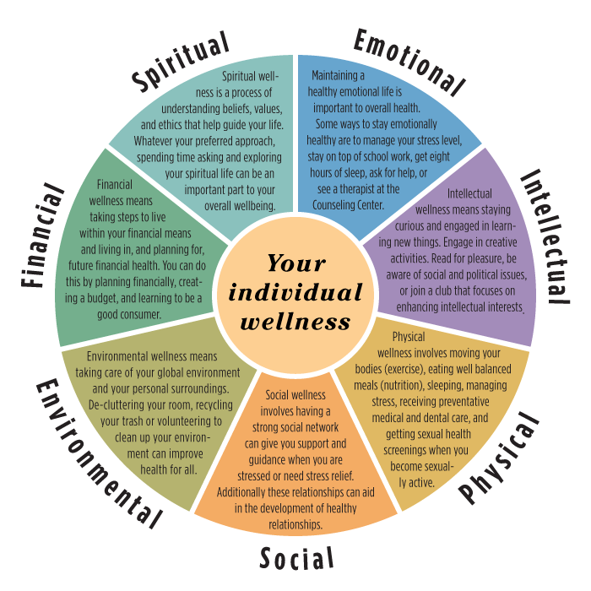
- is equally vital in the pursuit of optimum health

Health and Wellness
- Health is a state of complete __________, __________ and __________ well-being
= not merely the absence of disease or infirmity
- Wellness is the active process of ________ ________ ___ and _________ _______ __________ a healthy and fulfilling life.
= a positive approach to living
- Wellness has a direct influence on your overall health, which is essential if you are trying to reach your full potential as a person

Seven Dimensions of Wellness
There are seven dimensions of wellness: physical, emotional, spiritual, environmental, financial, social, and intellectual.

Emotional Wellness
Emotional wellness relates to understanding your __________ and coping effectively with __________. It is important to pay attention to self-care, relaxation, stress reduction and the development of inner resources so you can learn and grow from experiences.

Environmental Wellness
Environmental wellness inspires us to live a lifestyle that is respectful of __________ and your personal __________. Everyone can have a strong environmental conscious simply by raising their awareness.

Mental Wellness
Mental or intellectual wellness involves having an __________ __________ when you encounter new ideas and continuing to expand your __________. It encourages active participation in scholastic, cultural and community activities.

Physical Wellness
Physical wellness relates to maintaining a __________ __________ and seeking _________ when needed. Physical health is attained through exercise, eating well, getting enough sleep and paying attention to the signs of illness.

Social Wellness
Social wellness helps you perform __________ __________ effectively and create a__________ __________. This dimension of wellness allows you to not only develop encouraging relationships with peers, but also intimate relationships with romantic partners.

Spiritual Wellness
Spiritual wellness allows you to develop a set of __________ that help you seek __________ and __________ through religion, relaxation, etc. Being spiritually well means knowing which resources to use to cope with issues that come up in everyday life.

Financial Wellness
Financial wellness involves learning how to successfully __________ __________ __________ . Money plays a critical role in our lives. Not having enough of it impacts health and academic performance. Financial stress is a common source of stress, anxiety and fear.

Each dimension of wellness
- is interrelated with another
- is equally vital in the pursuit of optimum health
