Types of Chemical Reactions

Energy Changes and Chemical Reactions

Chemical reactions either release or consume energy. Often, thermal energy, called heat, is involved.

Changes that release heat to the environment are called exothermic.
- For example, the combustion of gasoline is written as:
gasoline + oxygen →carbon dioxide + water + heat

Reactions that absorb heat from the environment are endothermic.
- For example, the melting of ice is expressed as:
water _{(s)} + heat → water _{(l)}

As a general rule, when bonds within substances are broken, energy is absorbed (endothermic). When bonds are formed, energy is released (exothermic).

Categories of Chemical Reactions
- synthesis
- decomposition
- single displacement
- double displacement
- combustion

1. Synthesis Reactions
- involve the combination of smaller atoms and/or molecules into larger molecules

- has the general formula: A+ B → AB

For example: magnesium + nitrogen → magnesium nitride
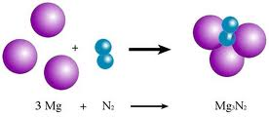
- also called combination reactions
2. Decomposition Reactions
- involve the splitting of a large molecule into elements or smaller molecules

- has the general formula: AB → A+ B

For example: the electrolysis of water
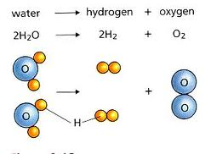

3. Single Displacement Reactions
- these are chemical changes that involve an element and a compound as reactants

- involve one element taking the place of (displacing) another element in a compound

- has the general formula: Z+ AB → ZB + A

Y + AB → AY + B

where metals replace metals and nonmetals replace nonmetals

For example:
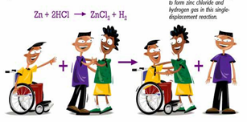
4. Double Displacement Reactions
- involves elements in different compounds displacing each other

- has the general formula: AB + XY → AY + XB

where A and X are metallic elements (cations)
B and Y are nonmetallic elements (anions)

For example:
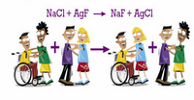

5. Combustion Reactions
- involve the rapid reaction of a substance with oxygen to produce compounds called oxides

- has the general formula: fuel + oxygen → oxides + energy

where fuel can be a variety of elements and compounds
energy is mainly in the form of heat and light

The most important fuel we burn is hydrocarbons – organic compounds containing only carbon and hydrogen. (E.g. gasoline, natural gas, propane, kerosene).

When hydrocarbons burn, they release carbon dioxide and water.

For example: hydrocarbon + oxygen → carbon dioxide + water + energy

