Chemical Reactions
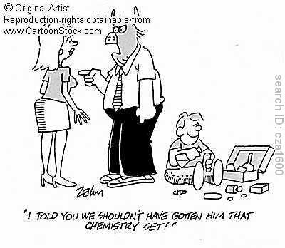
A chemical reaction involves the rearrangement of atoms to produce different substances. In other words, a chemical change is caused by a chemical reaction.

There are chemical reactions taking place everywhere and everyday. Lighting a match, starting a car, walking, and eating all involve chemical reactions.

What is a Chemical Equation?
- it tells the “story” of the chemical reaction

- it shows two things: (a) the substance(s) we start with (called reactants)
(b) the substance(s) we end with (called products)

- Reactants are written on the left side of the equation, and the products on the right.

- An arrow separates the reactants and products. It means “produces” or “yields”.

This is an example of a chemical equation:

Fe + S → FeS

This equation describes the chemical reaction that takes places when a mixture of iron (Fe) and sulfur (S) are heated. The Fe and S are the reactants. The FeS (iron sulfide) is the product.

Note:
- A coefficient (a number written in front of a chemical symbol) is used to tell how many molecules or atoms are reacting or being produced.

- If no coefficient is written, then assume there is 1 atom or molecule present.

- Sometimes the state of the chemical (e.g. solid, liquid, or gas) is important. To include this information, simply insert an abbreviation in brackets after each chemical formula.

For example: solid (s)
liquid (l)
gas (g)
aqueous solution (aq)

Does a Chemical Reaction Destroy or Create Matter?
- No! Atoms are not lost or gained during the chemical reaction, but only rearranged. They change the way they link up!

- The Law of Conservation of Mass states the mass of the reactants is equal to the mass of the products produced. This means the number of atoms on the reactant side must equal the number of atoms on the product side.

- In other words, matter can be changed in many ways, but it cannot be created nor destroyed.

Quick Check: Use the previous example to confirm the Conservation of Mass.

How many Fe in the reactants? _1_ How many Fe in the products? _1_
How many S in the reactants? _1_ How many S in the products? _1_

What about this example?

AlCl₃ + 3 KOH Al(OH)₃ + 3 KCl
Aluminum chloride and potassium hydroxide yields aluminum hydroxide and potassium chloride.

How many Al in the reactants? _1_ How many Al in the products? _1_
How many O in the reactants? _3_ How many O in the products? _3_
How many Cl in the reactants? _3_ How many Cl in the products? _3_

How to Write Balanced Chemical Equations

* There is no one set of solutions – it takes practice and patience – but try the suggestions below. *

1. Identify the reactants and products in the chemical equation.

2. Check to see whether there is the same number of atoms on each side of the equation. A good technique is to make a table of the atoms of each element on each side of the equation.

3. Is the number for each element the same in the reactants and products?
- If yes, the equation is balanced!

- If no, you need to balance the equation! Use coefficients placed in front of each substance to balance (aka ensure there is the same number of atoms on each side).

4. Repeat for the remaining substances.

5. Check the equation.

Try to balance the equation below:

__ Mg + __ O₂ → __ MgO

Steps 1 and 2
Reactants | Products
1 Mg | 1 Mg
2 O | 1 O

Step 3: Substances are NOT balanced – there is more O in reactants. Try adding a coefficient of 2 in front of MgO.

Step 4: Mg then needs to be changed. How about adding a 2 in front of Mg?

_2_ Mg + __ O₂ → _2_ MgO

Step 5:
Reactants | Products
2 Mg | 2 Mg
2 O | 2 O

We’re balanced!

