Introduction to Chemistry
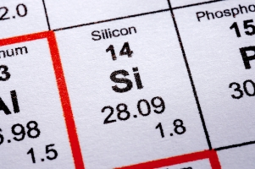
Our world is composed of several pure substances which cannot be broken down or changed into other substances using chemical means. These pure substances are called elements.

There are 118 elements, of which 92 are found in nature and 26 were produced in a laboratory.

All elements are included in the Periodic Table with their own symbols.

- Examples of chemical symbols are N (for the element nitrogen), He (for helium) and Pb (for lead).

- Symbols are the formal abbreviations for the element.

- They are universal to all languages and are written in the following way:
  - The symbol has 1 or 2 letters
  - The first letter is always capitalized
  - If present, the second letter is lowercase

In the periodic table, the elemental information is given as:
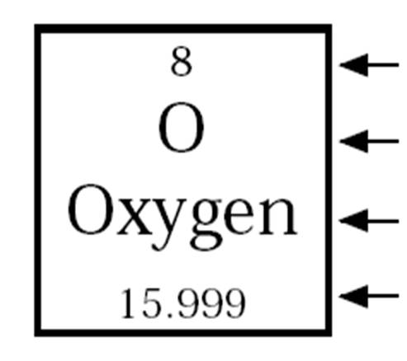
Atomic Number
Symbol
Element Name
Atomic Mass

Let’s practice… What is the symbol for each of the following elements?
- Silicon ____
- Copper ____
- Lead ____
- Tungsten ____
- Magnesium ____

Elements and Atomic Structure

Elements are composed of only one type of atom.

What is an Atom?
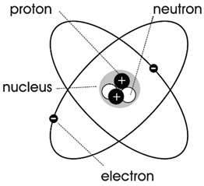
- Composed of three parts: protons, neutrons, and electrons

Protons and neutrons make up the center of an atom (called the nucleus). Together, they form the mass of the atom – called the atomic mass.

The electrons spin around the outside of the nucleus in areas called shells or orbitals. Electrons are very small and do not add much to the mass of an atom.

Protons have a positive (+) charge.
Electrons have a negative (-) charge.
A neutron is neutral, meaning there is no charge.

An atom has the same number of protons as electrons. [PROTONS = ELECTRONS]
This means that number of + charges = - charges. They balance each other. Because of this, an atom has no charge.

The atomic number is also the same as the number of protons. [PROTONS = ATOMIC NUMBER]

Three things are equal then: the number of protons, the number of electrons, and the atomic number.
P ROTONS =
E LECTRONS =
N UMBER (ATOMIC)

Therefore, if you know any one of these numbers you know the number of the other two – they are the same!

