What is Chemistry?

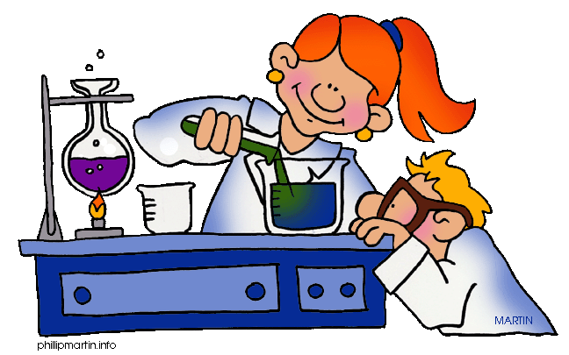
Chemistry is the study of matter!

We investigate its properties, structure, composition, behavior, reactions, interactions and the changes it undergoes.

Matter is anything that has mass. It is found in 3 states: solid, liquid, or gas.

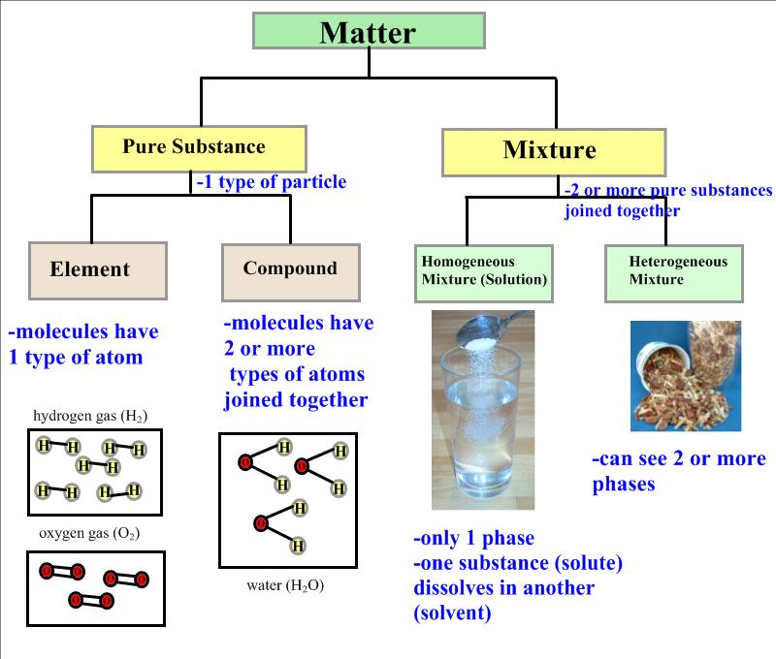
Properties of Matter
- can be used to identify what a substance might be

1. Physical Properties
- properties that can be observed or measured without changing the composition of the substance

Physical properties include: appearance, texture, melting point, boiling point, density, solubility, polarity, and many others.

2. Chemical Properties
- properties that have the "potential" to undergo some chemical change or reaction by virtue of its composition.

Chemical properties include: ability to burn, ability to oxidize, and ability to give off heat or absorb heat.

Changes of Matter

1. Physical Changes
- is a change in size, shape, or state where the composition of the substance does not change
- The same element or compound is present before, during, and after the change.

Examples:
Melting Point: As solid matter is heated it eventually melts or changes into a liquid state at the melting point.

Boiling Point: As liquid matter is heated further it eventually boils or vaporizes into a gas at the boiling point.

A common example to describe physical change is water.
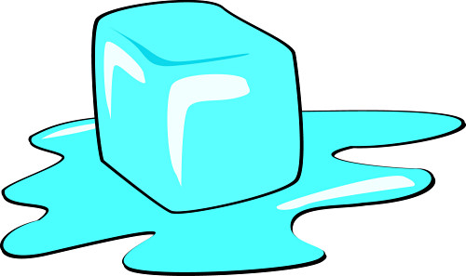
- Water is composed of hydrogen atoms and oxygen atoms. Whether water is in its liquid form, solid form as ice or gas form as water vapour, its composition is still H₂O.
- This is the same reasoning behind the tearing of paper or the crushing of rocks.
- There is no change in composition of the substance, but there is a change in the size of the substance.
Substances that are mixed together and can be separated by physical means undergo a physical change. Physical means of separation include processes such as distillation and filtration.

2. Chemical Changes
- is a change in the composition of the original matter
- Different elements or compounds are present at the end of the chemical change. The atoms in compounds are rearranged to make new and different compounds.

Oxidation of Iron: The rusting of iron is a slow chemical change since rust is an iron oxide with different properties than iron metal.

Signs that a chemical change has occurred:

1. If the original composition of the compound cannot be retrieved.
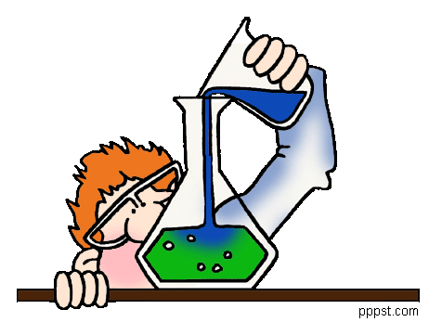
2. If there has been an explosion.
3. If there was release of heat or flames.
4. If there is a gas released.
5. If there is a colour change.
6. If there is an odour released.
7. If there is a formation of a solid or precipitate.

