The Mystery of the Bones
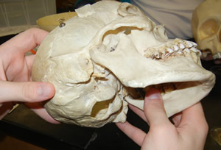
Objectives
- Understand what a forensic anthropologist does
- Reconstruct 4 "unknown" skeletons
- Determine the age, sex, height of the "unknowns"
- Investigate forensic art and its application in finding missing persons
- Determine the identities of the 4 "unknowns"

Section 1 - Research and Background
As a group, visit the following sites to gain an understanding of forensic anthropology and what bones (or remains) can tell you about the deceased. Be prepared to take a quiz (as a group) when you are finished. Write all answers on a separate page, you can turn in a single page for your entire group.

Investigative Techniques of Forensic Anthropology (http://www.pbs.org/opb/historydetectives/techniques/forensic_feature.html)
Mouse over the skeleton to answer these..
1. What can the teeth tell you about the deceased?
2. How can the skull be used to determine age?
3. How is the pelvis of a female different from the pelvis of a male?
4. The hand bones can help you determine what about the deceased?

Explore Forensics ( http://www.exploreforensics.co.uk/ ) - most can be found at the link: Analyzing the body
1. What is the first thing a forensic scientist looks at to identify a deceased?
2. Where is the most accurate place to take the body temperature? Suppose a body is found and its temperature is recorded at 34ºC, how long has the body been dead?
3. Why might a corpse be exhumed?
4. What insect is used to determine time of death? What type of scientist studies these insects?
5. What is rigormortis and how long does it last?
6. What is lividity?
7. What are the four categories of death?

Written in Bone - Exhibit at the Smithsonian ( http://anthropology.si.edu/writteninbone/index.html )
Skeleton Keys --> Bone Basics
1. What is the last bone to complete its growth?
2. How are teeth used to estimate age?
3. What is bone "remodeling" and how can it be used to determine age?
4. What girdle is the sciatic notch a part of? How can it be used to determine gender?
Forensic Case Files
5. Browse the cases and choose one that interests you. Describe the case and the key evidence used to solve it.

